

**Work Plan**

**Harvey Mudd College Engineering Clinic**

Project Team

**Fall Semester**

Robert Cyprus (S)

Aishvarya Korde (S)

Zayra Lobo (J)

Paige Rinnert (Fall TL)

Project Advisor: Professor Christopher Clark

Project Liaisons: Ken Dreshfield ‘80

Ian Jimenez ‘11

Ron P. Smith ‘83

Stephanie Tsuei (Lead)

December 2016

ABSTRACT

[Insert abstract here]

*An abstract is similar to a short executive summary. In about 100-150 words, it should summarize the report and the key results in a form accessible to the general reader (e.g. a junior engineering major). Common mistakes in an abstract are to use generalities and to omit the most important information.*

TABLE OF CONTENTS

ABSTRACT ii

1.1. Northrop Grumman 2

1.2. Project Statement 2

1.2.1. Objectives 3

1.2.2. Constraints 3

1.2.3. Functions 4

1.3. Deliverables 4

1.4. Project status 5

1.4.1. Simulation 6

1.4.2. Hardware implementation 6

1.5. Impact 6

1.6. Report overview 7

2. Background 8

3. design alternatives 10

3.1. States of the quadrotor 10

3.2. Sensors 10

3.3. SSE algorithm 11

3.3.1. Convex Optimization 11

3.3.2. Satisfiability Modulo Theory 12

3.4. Hardware 12

3.4.1. Quadrotor 13

3.4.2. Flight Computer 13

3.4.3. Flight Controller 14

4. Detailed design 16

4.1. Simulation 17

4.1.1. Dynamic Model 17

4.1.2. Control Feedback Simulation 17

4.1.3. Control Feedback Simulation with SSE 17

4.2. Hardware implementation 18

4.2.1. Hardware Connectivity 19

4.2.2. Onboard Computer 19

4.2.3. Sensors 21

4.2.4. Quadrotor 25

4.2.5. Flight controller 26

4.2.6. RC Receiver 26

4.2.7. Power Grid 27

5. Results 29

5.1. Dynamic model 29

5.2. Closed-loop simulation 29

5.3. SSE algorithm 29

5.4. Sensor data 29

5.4.1. 9DOF sensor 29

5.4.2. Laser scanner 29

6. Project Management 31

6.1. Fall progress 31

6.2. Spring overview 32

6.3. Work breakdown structure 32

6.4. Schedule 33

6.5. Division of labor 33

7. References 34

8. Appendix 35

8.1. Dynamic model 35

8.2. Simulation with Luenberger observer 35

8.3. Simulation with SSE algorithm 35

introduction

Northrop Grumman (NG) is sponsoring a 2016-2017 Clinic Project to test sensor robustness from cyber-attacks on autonomous vehicles, specifically aircraft. This section describes NG, presents the project statement, defines the deliverables for the project, and outlines the current project status at the end of the fall semester.

## Northrop Grumman

Northrop Grumman is a leading global security company that innovates in the fields of autonomous vehicles, cyber security and communications, and air and space systems. NG is committed to preserving freedom and advancing human discovery. This Clinic Project is sponsored by NG’s Aerospace Systems sector, NGAS. NGAS is based in Redondo Beach, CA and provides next-generation solutions for military aircraft and land vehicles, autonomous systems, and space systems for its customers worldwide. NG holds world records in many fields, with technology integrated in products ranging from cell phones to space satellites. NGAS’s Research and Development department is sponsoring this project to test sensor robustness in autonomous aircraft.

## Project Statement

The Northrop Grumman Clinic Team will implement a secure state estimator (SSE) in software and then experimentally validate the estimator in hardware. The team will demonstrate that the addition of the SSE algorithm to the control loop reduces the real-time tracking error of a quadrotor when using measurements from compromised onboard sensors.

### Objectives

* Demonstrate quadrotor altitude tracking control with minimal tracking error [m]
* Maximize the number of compromised sensors for which the SSE can be tested
* Minimize cost

### Constraints

* SSE must reduce tracking error when sensors are compromised, as seen in Figure 1.

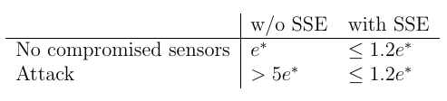

Figure | Specifications for a successful SSE

The tracking error when no sensors are compromised will be some value that depends on the specifics of the flight hardware and controller. Adding the SSE to the system may increase the error slightly but the error should exceed no more than 120% of the original error. The team’s goal is to show that when compromised sensors would cause the tracking error of the system with a traditional estimator to increase to 5 times the original error, the SSE keeps the error bounded in the same range as when all sensors are functioning normally.

* Final implementation of the SSE must be in ROS
* Quadrotor must fly for 10 minutes on a single battery charge
* Must estimate states at a frequency of at least 25 Hz
* Equipment and supplies < $7,000

### Functions

* Quadrotor should complete pre-planned altitude profile with compromised sensors
* Quadrotor should perform real time state estimation and correction
* The SSE must be configurable to simulate hacking
* The SSE should estimate the state of the quadrotor (position [m], velocity [m/sec], orientation [°], angular velocity [°/sec])

## Deliverables

By the end of the fall semester, the team will:

* Implement and simulate a state estimator in Matlab with
  + All sensors functioning.
  + Some sensors compromised.
* Successfully log sensor data.
* Produce a functioning quadrotor with onboard computer, controller, and sensors.
* Project documentation and presentations including:
  + Work Plan
  + Midyear Report
  + Design Review at Northrop Grumman
  + Three internal Clinic presentations

By the end of the spring semester, the team will:

* Test state estimator on real sensor data with
  + Some corrupted measurements.
  + Offline and in real time.
* Demonstrate quadrotor flight with real time data logging and state estimation.
* Project documentation and presentations including:
  + Final Report (including engineering drawings)
  + Spring semester presentation at HMC
  + Projects Day presentation
  + Final Presentation at Northrop Grumman

The fall deliverables in the Work Plan had called for a functioning quadrotor with an onboard computer, controller, and sensors. Due to the lead time in getting the quadrotor to Harvey Mudd, the HMC team did not have enough time to assemble all components onto the quadrotor. The flight hardware will be assembled at the beginning of the Spring semester, and the team does not expect this delay to affect the team’s ability to complete the Spring deliverables as initially planned.

## Project status

This section summarizes what the team has achieved so far and the status of the fall semester deliverables and is broken into two categories: the status of quadrotor and SSE simulations and the status of hardware implementation. The simulation subsection focuses on the dynamic model of the quadrotor, coding the SSE in MATLAB/Simulink, closing the control loop in simulation, and other simulation aspects of the project. The hardware implementation subsection focuses on the onboard computer, controllers, sensors, power and hardware connectivity, as well as the Optitrack system, used for position and orientation verification, quadrotor frame, and netting.

### Simulation

### Hardware implementation

The hardware that the team needs to implement falls into three categories: sensors, computers, and the quadrotor. The sensors to be used for this project are three accelerometers, three gyroscopes, three magnetometers, and a laser scanner. The three accelerometers, gyroscopes, and magnetometers are integrated on a 9DOF IMU (inertial measurement unit). The laser scanner and IMU will send data to the Jetson TK1, the computer onboard the quadrotor, which will determine the quadrotor’s state using the implemented SSE. The Jetson will also be connected to a Pixhawk PX4 Flight Controller, which controls the motors of the quadrotor. The Jetson is currently able to log data from two laser scanners simultaneously, and the 9DOF IMUs will be tested and calibrated before the end of the semester. The team is working on the Pixhawk to Jetson connectivity, and the two will be able to send data to each other before the end of the semester. The quadrotor frame will be delivered in early December, so the team can then begin assembling the sensors and computers on it to produce a fully functioning quadrotor that logs data. The team also has purchased an RC controller and receiver to communicate directly with Pixhawk while the quadrotor is in flight.

## Impact

This project is non-proprietary, which means that the technology the team produces will be owned by the team instead of becoming the property of Northrop Grumman. Such ownership of the project provides the team with significantly more control over the distribution of the project results were owned by Northrop Grumman.

Since the overall goal of the project is to improve the state estimation of quadrotors, the success of the project could inform observer design for quadrotors in popular applications, including wildlife monitoring and structural testing. Northrop Grumman, being a defense and aerospace company, hopes to use the results of the project to improve military drones for the United States government. If the team chose to publish this project’s results publicly, quadrotors used for commercial delivery services, photography, mapmaking, lifeguarding, or other such activities could also improve their state estimation. By enhancing the state estimation capabilities of quadrotors, these devices would become more robust and less prone to failure while in use. The team is aware that the results of this project will likely be used on military drones, and the team also hopes to publish the study’s results publicly so that quadrotors in non-military applications will also benefit from these findings.

## Report overview

The background research about secure state estimation is outlined in Section 2. Section 3 discusses the design alternatives and the selection process for the system states, onboard sensors, SSE algorithm, and onboard hardware (computer and controller). Section 4 gives a detailed design of all simulations, which include the dynamic model and control loop with SSE, and hardware implementations, including all sensors, onboard computer, onboard, controller, quadrotor frame/motors, RC transmitter/receiver, and power components. The current results of these designs will be stated in Section 5. This report will conclude with an overview of tasks and work breakdown for the Spring semester, outlined in Section 6.

# Background

Quadrotors are beginning to be used in a variety of applications from product delivery to agricultural maintenance and humanitarian aid. Even though quadrotors may appear in a wide range of environments, each of these contexts has something in common: the quadrotor must have a robust control system to follow the user’s desired trajectory as accurately as possible. Most control systems use feedback control, where a controller calculates necessary inputs based on the desired trajectory and previous system outputs. The controller then feeds these inputs back into the system to help the quadrotor stay on the correct path. However, a control system is only as good as the states fed into the controller.

Estimating the states of a real system, like position and orientation, is a challenge given that the exact state cannot be determined simply by observation. Instead, the state must be estimated given a set of measurable parameters of the system. The goal of state estimation is to provide an estimate of the system state given the inputs and outputs of the real system; this state can then be fed into a standard controller to maneuver the vehicle.

Standard state estimation techniques are sufficient when all sensors are functioning as expected, but these methods break down when sensors become compromised. If a sensor starts to output incorrect or nonsensical values, a standard state estimator will not produce an accurate measure of the system state. Therefore, the focus of this project is to implement a *secure* state estimator on a quadrotor that accurately measures states of the quadrotor in the presence of cyber-physical attacks. The category of cyber-physical attacks includes both cyber attacks, like a malicious virus introduced to a system or a signal that is intercepted and altered by a hacker, and physical attacks on the hardware. Both cyber and physical attacks could cause a state estimator to fail to produce an accurate state of the system if they alter the sensor outputs. These types of attacks can also affect the behavior of the controller and even the actuators that provide control input, but given the scope of the project, the team is focusing only on attacks on sensors, in the form of broken sensors, compromised signals, or noisy outputs.

One of the main techniques employed to write a secure state estimator that is robust against attacks is convex optimization. (Another option is satisfiability modulo theory, but this approach will not be discussed in detail.) Convex optimization is a special class of nonlinear optimization problems that includes least squares programming (LP) and quadratic programming (QP). Many different programs exist to translate a mathematical problem into a useful form for optimization and to find the solution. Convex optimization is used in a wide array of fields, including control, circuit design, economics, and machine learning. Recent advances have drastically reduced solution times, which makes it possible to use a convex optimization solver in real time on a physical system like a quadrotor [1]. In this project, the team is using the CVX solver to implement the secure state estimator because it is compatible with Matlab and Simulink. The team’s goal is not to improve the state estimation algorithm; the aim is to implement a pre-existing algorithm that has only been tested in simulation and valid the algorithm in hardware.

# design alternatives

The team considered many options for the states of interest, the sensors to measure these states, the algorithm to perform state estimation, and the type of quadrotor and other flight hardware to purchase. This section details the team’s process for selecting each of these components and the final implementation decision.

## States of the quadrotor

This subsection delineates the states that the team will be tracking. The states the team is most interested in are states necessary to control the quadrotor and track a flight path. The team will need sufficient states in order for the quadrotor to perform autonomous navigation. The proposed states are included in Table 1:

|  |  |  |
| --- | --- | --- |
| Position | Each of X, Y, and Z in a global frame | Note: The global origin will be set to the take-off position. |
| Velocity | Each of X, Y, Z directional velocities |  |
| Orientation | Each of Roll, Pitch, and Yaw |  |
| Angular Velocity | Each of Roll, Pitch, and Yaw time derivatives |  |

Table | Quadrotor states

## Sensors

The team must select sensors to measure the states mentioned in Section 3.1, and these sensor outputs will be input to the SSE. The list of sensors the team considered is included in Table 2 (underlined sensors are sensors that the team selected to purchase):

|  |  |
| --- | --- |
| **3-DOF Position & Velocity** | **3-DOF Orientation & Angular Velocity** |
| Accelerometers  Laser scanner | Magnetometers  Gyroscopes |

Table | Sensors and associated states

The accelerometers, gyroscopes, and magnetometers are combined on a 9DOF IMU (inertial measurement unit). The team will be using an OptiTrack camera system to determine the true states of the quadrotor or to possibly transmit the position measurements to the Jetson TK1 onboard the quadrotor.

## SSE algorithm

The team considered two main approaches for the secure state estimation algorithm, based on literature suggested by the liaisons. The first algorithm uses concepts from compressed sensing and error correction over the reals to pose the estimation problem as a convex optimization problem [2]. The other algorithm uses Satisfiability Modulo Theory to perform state estimation on nonlinear systems [3]. The team decided to use the convex algorithm because of previous coursework and familiarity with state space control, but both algorithms will still be described here.

### Convex Optimization

This secure state estimation algorithm is presented in as a convex optimization problem:



Equation | Convex optimization algorithm

where $D_{1,r}^{T}$ is a decoder whose inputs are the sensor output column vectors $y^{(0)},⋯ ,y^{(T-1)}$ (1 by the number of sensors); *argmin* for a vector $x$ of real values denotes the states $x$ for which the argument is minimized; $Y^{(T)}$ contains the matrix of outputs $\left[y^{(0)} | y^{(1)} | ⋯ |y^{(T-1)}\right]$ (number of time steps $T$ by number of sensors) added to the control inputs $\left[CBu^{(0)} | CABu^{\left(0\right)}+CBu^{\left(1\right)} | ⋯ | CA^{\left(T-1\right)}Bu^{0}+⋯+CBu^{\left(T-1\right)}\right]$, where $B$ is one of the system matrices; $Φ^{(T)}x$ is the linear transformation that maps $x$ to $\left[Cx | CAx | ⋯ | CA^{(T-1)}x\right]$ using the system matrices $A$ and $C$; and the notation ${\left\|M\right\|}_{l_{1}/l_{r}}$ is the sum of the $l_{r}$ norms (also known as a $p$-norm) of the rows of matrix $M$ [2].

### Satisfiability Modulo Theory

The other state estimation algorithm is formulated in as a Boolean equality:



Equation | SAT algorithm

where $Φ$ is a pair $(x,b)$ that satisfies the following Boolean expression; $p$ is the number of sensors; $b_{i}$ is a Boolean value indicating whether sensor $i$ is compromised ( $b_{i}=1$ indicates that the sensor has been attacked); $Y_{i}(t)$ is a column vector of sensor measurements from the $i^{th}$ sensor where the first element is the measurement from the beginning of the window (at time $t-τ+1$) and the final element is at the end of the window (at time $t$); $H_{u,i}(x^{*})$ is the system transfer function; the notation ${\left\|M\right\|}_{2}^{2}$ is the $l_{2}$ norm of the matrix $M$ squared; and $\overline{s}$ the upper bound on the number of compromised sensors [3].

## Hardware

This section details the flight hardware the team is considering for purchase, including the quadrotor frame, onboard computer, and flight controller.

### Quadrotor

The team needs a quadrotor that is lightweight and customizable to incorporate the sensors necessary for state estimation. The team also needs to be able to simulate different sensor outputs to test how the estimator responds to faulty inputs. The Northrop Grumman liaisons suggesting buying the QAV400 Quadrotor frame shown in Figure 2.

The QAV400 quadrotor frame fits the requirements for the project – it is lightweight (375g) and durable and can be purchased individually, allowing the team liberty in choosing the flight control unit, sensors, actuators, and on-board computer [4].

A benefit of buying this quadrotor is that Lumenier sells the frame with electronic speed controllers (ESCs) and motors that are compatible in size and power with the team’s chosen controller and 4S LiPo battery.



Figure | Quadrotor QAV400 Frame

### Flight Computer

Since the team will implement the algorithm using ROS, the Northrop Grumman liaisons suggested using the Jetson TK1 computer board. The Jetson TK1 natively runs the Ubuntu 14.04 Nvidia operating system and is equipped with 1 USB A, 1 micro-USB, 1 HDMI, 1 RS232 (DB-9), expansion I/O (75 pins total), 1 Ethernet, 1 SD card reader port, and much more, which will help the team implement and test different sensors [5].

The team selected the Jetson TK1 over other similar options, such as a Raspberry Pi 3, since the Raspberry Pi’s do not have as many GPIO pins, memory, nor processing power as the Jetson TK1. The Nvidia Jetson TX1 is three times as expensive as the TK1, and the TX1’s extra graphics capabilities would not have been utilized to make up the cost increase. The Jetson TK1 is shown in Figure 3.



Figure | Jetson TK1

### Flight Controller

Having a controller on board is essential for flying the quadrotor. Since the focus of the project is implementing the secure state estimation algorithm, the team decided to use an off-the-shelf controller for the quadrotor, instead of writing a custom one. The 3DR Pixhawk flight controller is appropriate for the project’s needs. The Pixhawk is a fitting option because of the open-source software and firmware. This open-source availability is necessary for multiple reasons; the team must be able to integrate the SSE software with the quadrotor and its flight controller, and ensure that the existing controller does not interfere with the results of the estimator [6]. Northrop Grumman also uses Pixhawk controllers on many of their quadrotors. The 3DR Pixhawk controller can be seen in Figure 4.



Figure | 3DR Pixhawk Controller

# Detailed design

*This section is often the heart of a Midyear Report. It should fully document the design. Common figures and tables in this type of section include block diagrams, detailed drawings, schematics, printed circuit board layouts, and a bill of materials (BOM). The section should explain why design decisions were made, such as how tolerances were selected or why certain component values were used.*

*A bill of materials should list everything that the reader would need to order the components. Component designations should match those in the detailed drawing or schematic to assist assembly. An example is shown in Table 3.*

Table 3 Bill of Materials

|  |  |  |  |  |  |  |
| --- | --- | --- | --- | --- | --- | --- |
| **Component** | **Description** | **Supplier** | **Supplier Part #** | **Unit Price** | **Quantity** | **Total** |
| R1-R7 | 1 k resistor | DigiKey | 1.0KQBK-ND | $0.01 | 7 | $0.07 |
| C1 | 0.1 F capacitor | DigiKey | P4525-ND | $0.18 | 1 | $0.18 |
| U1 | Spartan XCS3400-4TQ144C FPGA | Nu Horizons | XCS400-4TQ144C | $19.10 | 1 | $19.10 |
| D1 | Common anode 7-segment display | Jameco | 24715 | $1.26 | 1 | $1.26 |
| … |  |  |  |  |  |  |

*If the design includes source code, the body should give an overview of the design and operation, but the code should be placed in an appendix.*

## Simulation

### Dynamic Model

### Control Feedback Simulation

### Control Feedback Simulation with SSE

The first step in simulating the SSE algorithm was implementing the algorithm in a language the team was comfortable with. Based on the liaisons’ suggestion, the team used CVX, a convex optimization solver that is compatible with MATLAB [7]. The core of the algorithm is included below in Figure 5:

Figure | SSE algorithm in MATLAB CVX

The algorithm is designed to estimate the state of a linear system, so the quadrotor dynamic equations must be transformed into state space and linearized. The state space representation of the quadrotor equations of motions are shown in Equation 3:

$${\dot{x}}_{3}=x_{6}$$

$${\dot{x}}_{4}=- \frac{k_{d}}{m}x_{4}+\frac{1}{m}\sin{x_{8}}\sin{x_{9}}(u_{1}+u_{2}+u_{3}+u_{4})$$

$${\dot{x}}_{5}=- \frac{k_{d}}{m}x_{5}- \frac{1}{m}\cos{x_{9}}\sin{x_{8}}(u_{1}+u_{2}+u_{3}+u_{4})$$

$${\dot{x}}_{6}=-g -\frac{k_{d}}{m}x_{6}+ \frac{1}{m} \cos{x_{8}}(u_{1}+u_{2}+u_{3}+u_{4})$$

$${\dot{x}}_{7}=x_{10}+\frac{\sin{x_{8}}}{\sin{x_{7}}(\cos{x_{8}}+\sin{x_{7}})}x_{11}+ \frac{\tan{x_{8}}}{\cos{x_{8}}+\sin{x_{7}}}x_{12}$$

$${\dot{x}}_{8}= \frac{1}{\cos{x_{8}}+\sin{x_{7}}}x_{11}-\frac{1}{\cos{x_{8}}+\sin{x_{7}}}x_{12}$$

$${\dot{x}}_{9}=\frac{1}{\cos{x_{8}}(\cos{x_{8}}+\sin{x_{7}})}x_{11}+ \frac{1}{\cos{x_{8}}\tan{x_{7}}(\cos{x_{8}}+\sin{x_{7})}}x_{12}$$

$${\dot{x}}_{10}=\frac{I_{yy}-I_{zz}}{I_{xx}}x_{11}x_{12}+I_{xx}^{-1}Lk(u_{1}-u_{3})$$

$${\dot{x}}_{11}=\frac{I_{zz}-I_{xx}}{I_{yy}}x_{10}x_{12}+I_{yy}^{-1}Lk\left(u_{2}-u_{4}\right)$$

$${\dot{x}}_{12}=\frac{I_{xx}-I_{yy}}{I_{zz}}x_{10}x_{11}+I_{zz}^{-1}b(u_{1}-u_{2}+u_{3}-u_{4})$$

Equation | Quadrotor equations of motion in state space

where the vector $[x_{3}⋯ x_{12}]'$ corresponds to $[z v_{x} y_{y} v_{z} θ ϕ ψ ω_{x} ω_{y} ω_{z}]'$ (height; velocity in x, y, and z; orientation in x, y, and z; and angular velocity in x, y, and z) and $[u_{1} u_{2} u_{3} u_{4}]'$ corresponds to the control inputs on the four motors.

Once the equations of motion have been formulated in state space, the system can be linearized by separating the terms containing $u_{1}⋯ u_{4}$ from the terms containing only state variables. Calculating the Jacobian of each set of equations and evaluating at the desired fixed point yields the $A$ (size n by n) and $B$ (size n by 4) matrices of the state space system, which are shown in Equation 4:

$$\dot{x}\left(t\right)=Ax\left(t\right)+Bu(t)$$

$$y\left(t\right)=Cx\left(t\right)+Du(t)$$

Equation | Generalized state space equations

The matrix $C$ is the identity matrix (size 10 by 10), because every state is being measured directly so there is full state feedback, and the matrix $D$ is zero because the inputs do not feed directly back to the states. The matrices $A$ and $C$ are then fed into the state estimator.

## Hardware implementation

This section discusses the hardware implementation of the components in this project, both onboard and off-board the quadrotor. This includes the onboard computer, the on and off-board sensors, the quadrotor itself, the onboard controller, the RC receiver, and the power to all necessary components.

### Hardware Connectivity

Since one of the project constraints is real time processing, nearly all involved hardware must be onboard the quadrotor. Figure 6 shows the connectivity of the onboard computer, controller, sensors, motors, and power. Each of these components are outlined in this section.



Figure | Onboard Hardware Connectivity Diagram

### Onboard Computer

The onboard computer is the Jetson TK1, where all processing is done aboard the quadrotor. The Jetson has a separate wired connection to each onboard sensor (outlined in Section 4.2.3), and is continually receiving data in real time. A ROS environment is used to manage all the asynchronous processing, including simultaneously receiving data from multiple sensors, processing that data with an SSE algorithm, and sending signals to the Pixhawk controller.

#### ROS Environment

The ROS environment on the Jetson facilitates the asynchronous data sending, receiving, and use by different sensors and applications on the Jetson. In this project, the team has decided to use ROS-Indigo, two versions behind the most recent release of ROS, ROS-Kinetic. This design choice was made to keep the same version of Ubuntu (14.04) and ROS as Northrop’s Autonomous Systems R&D department uses.

Each laser scanner and 9DOF sensor is a ROS node that publishes data as separate rostopics. The SSE runs as another node, collecting published data and outputting state estimations. Finally, there is a node that sends state estimates to the Pixhawk controller.

#### SSE Algorithm

While the SSE algorithm was implemented in MATLAB for simulation, MATLAB is not practical for the SSE on the quadrotor because MATLAB does not run fast enough for real-time data collection and processing. The team is considering two options for implementing the SSE on the quadrotor. The first option is to use CVXgen, a language that allows the user to formulate a mathematical problem in an online interface and generate C code [8]. The team has started the process of translating the SSE algorithm into the CVXgen language, but the limited number of functions available to the CVXgen user may not be sufficient to implement the full algorithm. The second option is to write an optimization solver in a MATLAB s-function for Simulink code generation. Writing this kind of a solver is more involved than the CVXgen interface but will afford more flexibility. The team will decide which approach to use to implement the SSE algorithm in C early next semester.

#### Data Logging

Data logging on the Jetson is somewhat straight forward. Since the team uses ROS onboard the Jetson, data sets from the sensors are published as rostopics, accessible by other nodes in the ROS environment.

However, the published data in rostopics are only accessible while the programs are running. Therefore, if the team wants access to the received sensor data for offline analysis, the rostopic data needs to be copied to another location. This can be accomplished by executing simple scripts through the Jetson’s command-line interface to copy data to an offline directory.

### Sensors

The team has decided to use two different sensors onboard the quadrotor to measure all the relevant states of the system: a 9 degree of freedom IMU and a laser scanner. A third sensor, the Optitrack vision system, has been set up to produce truth data to use to calculate the tracking error.

#### 9DOF Sensor

The 9DOF IMU that the team will be using includes three accelerometers, three gyroscopes, and three magnetometers to measure the motion of the quadrotor on nine axes of movement. It can communicate in either SPI or I2C, which means it can be connected directly to the SPI pin on the Jetson TK1. It requires 3 to 5 V for power, and the maximum ranges for each of the components on it are ±16 G for the accelerometers, ±2000 dps for the gyroscopes, and ±4800 μF for the magnetometers. As stated in Section 3.2, the accelerometers will be used to track the quadrotor’s 3DOF position and velocity states and the magnetometers and gyroscopes will be used to track the 3DOF orientation and angular velocity states.



Figure | 9DOF IMU [9]

#### Laser Scanner

The team selected the Hokuyo URG-04LX-UG01 Scanning Laser Rangefinder as the laser scanner for the quadrotor. In a plane, the laser scanner returns distances of the nearest object in a 240-degree scan. The resolution is 0.001m with a guaranteed accuracy of 0.03m. The laser scanner updates its measurements at a frequency of 10Hz. This scanner is shown in Figure 8.



Figure | Laser Scanner Rangefinder [10]

The device is connected to the Jetson TK1 through a USB hub, since there are multiple laser scanners connected and only one USB-A port on the Jetson. Hokuyo provides ROS drivers and wrappers for this laser scanner in C. These were downloaded and slightly altered such that multiple lasers can be connected and logging data simultaneously. This was accomplished by defining a new rosparam when initializing each laser scanner as a rosnode to run. The wrapper was also changed to log each connected laser to a different rostopics so different lasers wouldn’t overwrite each other’s data.

#### Optitrack vision system

The team is using the Optitrack Vision System (Optitrack) as a ground truth replacement for GPS, since testing will be completed indoors where GPS is not available. Optitrack is capable of tracking objects with six degrees of freedom – 3DoF position and 3DoF orientation [11]. Early in the design phase, the team considered sending Optitrack data to the quadrotor as sensor inputs. While this is still a possibility, the team currently only plans to use Optitrack data for ground truth comparisons to state estimations. In the Spring semester, if the team determines it essential for data to be wirelessly transmitted from the Optitrack system to the quadcopter’s onboard computer, the team will take the necessary measures. In the team’s clinic space, the Optitrack cameras are set up on the ceiling, pointing towards the space in which the quadcopter will be flown, shown in Figure 9.



Figure | Optitrack Camera Setup

Calibrating the Optitrack system requires a calibration stick with IR-reflective spheres, shown in Figure 10 (a). The IR-reflective spheres have a known radius and are spaced at known distances. The lower part of Figure 10 (b) shows each camera on the calibration screen. The colorful splotches in the boxes are the views of each of seven cameras logging the movement of the calibration stick. Optitrack combines this data from every camera to obtain the global position of the calibration stick.



Figure | (a) Optitrack Calibration Tool (b) Optitrack Calibration Screen

When using Optitrack to track an object, small IR-reflective spheres must be attached to that object, and more IR spheres improves the tracking accuracy. Optitrack will define a “rigid body” from the IR-reflective spheres, assuming they do not move relative to one another on the object during flight. The object can then be tracked through Optitrack’s interface using visible and IR light. The team currently plans to attach the IR-reflective spheres to the quadrotor using two-sided tape, and this will be completed in the Spring semester.

### Quadrotor

The frame that the team purchased is the QAV400. When mounting the sensors, computers, and battery on this frame, the center of gravity will have to be kept as close to the center of the frame as possible so that the quadrotor can fly stably. If the quadrotor becomes too heavy to fly after mounting all of the components on the frame, material may have to be removed from the frame to make it lighter.

### Flight controller

The Pixhawk PX4 Flight Controller will be used to control the motors on the quadrotor. The Pixhawk already has a state estimator implemented on it, but the team will disable that estimator so the Jetson can use the SSE to send states to the Pixhawk.

A USB to FTDI cable connects the USB port of the Jetson to a DF13 6 position cable that then connects to the serial port of the Pixhawk. The Pixhawk and Jetson should thus be able to send data to and receive data from one another, which will be necessary for the Jetson to send states to the Pixhawk and for the Pixhawk to send control inputs back to the Jetson.

### RC Receiver

The team is using a Turnigy 9X RC transmitter and its corresponding eight-channel receiver. The receiver connects to a PPM encoder, which combines the pulse-width modulation (PWM) signals of the receiver into a single signal using pulse-position modulation (PPM). The PPM encoder then sends the signals to the RC input port on the Pixhawk, which manipulates the motors based on these input signals.

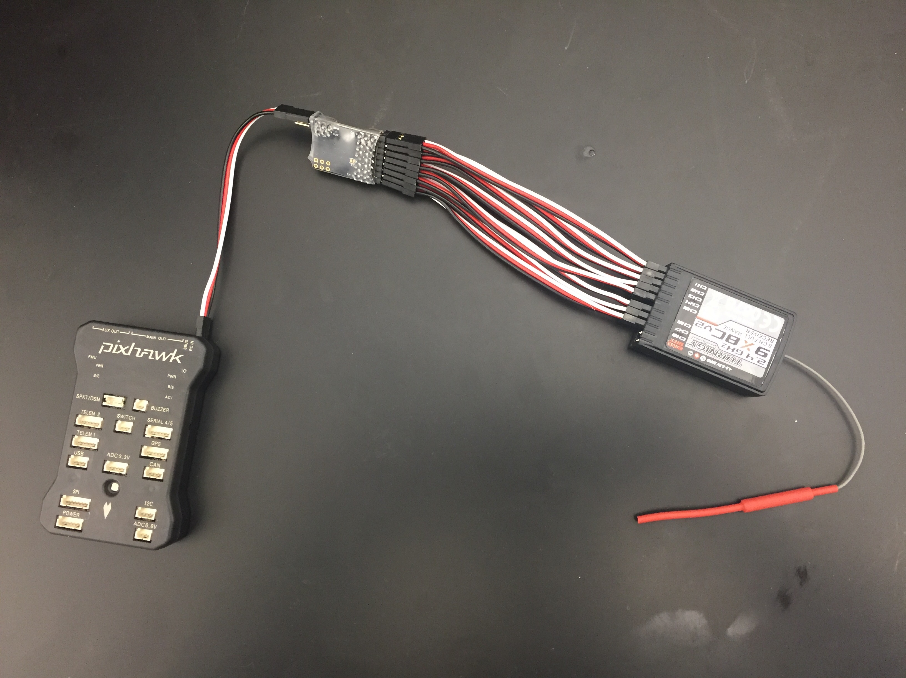

Figure | RC Receiver Connection to Pixhawk

### Power Grid

A 14.8 V LiPo battery will power the quadrotor, with the appropriate voltage regulators stepping down the voltage to power the Jetson, Pixhawk, and motors. A 12 V regulator will connect the LiPo to the Jetson, and the corresponding voltage regulators will connect the motors and Pixhawk to the LiPo as well.

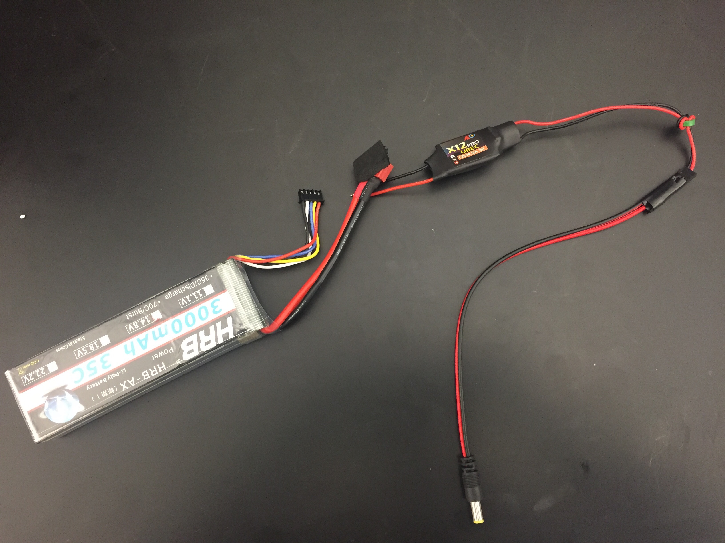

Figure | Components for Jetson Power Supply

# Results

## Dynamic model

## Closed-loop simulation

## SSE algorithm

## Sensor data

This section looks at data from the onboard sensors logged and published through ROS. There is not much analysis on the data, just that the data is being received. Another program in Python or C will be written to process this data and format it in such a manner that the SSE can use.

### 9DOF sensor

### Laser scanner

The laser scanner range finders, model URG-04LX-UG01, each log data to separate rostopics while running. Figure 13 shows a sample output in the rostopic for one of the laser scanners. The fields can be described as follows:

* seq: log entry number for that laser since the ROS node was created and began to run
* stamp: time stamp, in seconds and nanoseconds
* angle_min: -2.35619449615 rad = -135 degrees, minimum programmed scan angle
* angle_max: 2.35619449615 rad = 135 degrees, maximum programmed scan angle
* angle_increment: 0.00436332216486 rad = 0.25 degrees
* scan_time: 0.025 seconds
* range_min: 0.02 meters, min programmed range
* range_max: 5.6 meters, max programmed range
* ranges: Vector of 1081 (270 degrees / 0.25 degrees + 1) distance measurements at corresponding angles, starting at angle_min, ending at angle_max



Figure | Laser Scanner Sample Output

The original drivers downloaded from the manufacturer’s website [12] did not compile, so the team made alterations. After being updated, the drivers are now able to connect to the lasers, receive data, and format the data in a meaningful way to allow for multiple lasers to be connected simultaneously, and the laser scanners function as expected.

# Project Management

*By this point, you will likely have obtained new information not available at the time of the Work Plan that causes the plan for the project to shift in minor or major ways. You also are likely to have a much better sense of which parts of the project are easy and which parts are hard. This section is a good place to critically reflect on how the fall semester actually proceeded in comparison to your plan and to use the experience to create an effective spring plan.*

[Introduction here, you should not have two headings in a row without text between.]

## Fall progress

*Discuss what the team completed in the fall and how it matched the Work Plan in terms of deliverables, schedule, and division of labor. Include a comparison of the fall elements from the work breakdown structure with the actual work performed. The comparison will show new tasks added to the work beyond the original plan. Review the minutes from the team meetings. If the project deviated from the plan, why did the deviations occur? What can the team learn from the experience to create a more realistic plan to reach the spring deliverables?*

…

**Activity Planned Time (hours) Actual Time**

Background research *(already complete)*

Roadrunners

Diet 6 7

Habitat 6 5

Locomotion 6 3

Existing Acme products 6 8

Review footage of product failures 3 × 4 = 12 12

Conceptual Design

Research

Skates 12 8

Boulders 12 9

Anvils 12 7

Jet-Powered Anvils new 4

Brainstorming, sketching, component research

Skates 18 13

Boulders 18 15

Anvils 18 12

Jet-Powered Anvils new 9

Drawings

Skates 4 7

Boulders 4 8

Anvils 4 5

Jet-Powered Anvils new 9

Comparison of Alternatives 5 × 4 = 20 16

Detailed Design *(significant uncertainty in these initial estimates)*

Initial SolidWorks model 24 18

Finite Element analysis 48 60

(note: ideally this would be broken down further to better estimate time)

Component selection 20 30

Manufacturer selection 12 7

Send prototype for manufacturing 8 not done

Test Plan

Initial Test Plan 8 9

Team Meetings

Teleconferences 15 × 4 × 1 60

Internal Team Meetings 15 × 4 × 1 60

Tuesday Presentations 15 × 4 × 1 40

Team Leader Meetings 3 3

Planning 15 × 0.5 8

Logistics

Register to drive Clinic Van 2 1

Presentation and Preparation

Orientation Day 3 × 4 = 12 12

Fall Review #1 2 × 4 = 8 8

Fall Review #2 3 × 4 = 12 12

Fall Review #3 3 × 4 = 12 12

Fall Site Visit 12 × 4 = 48 55

Reports

Team Charter 5 6

Work Plan

Background 5

Design Alternatives 5

Project Management

Work Breakdown 4

Schedule 2

Division of Labor 1

Other sections 3

Writing Center review 2

2nd Draft n/a

3rd Draft n/a

Midyear Report 40

Total Time (Fall) (add up here) (add up here)

Figure | Comparison of Planned and Actual Fall Work Breakdown Structure

## Spring overview

[Lay out the big picture of what the team plans to do in the spring, how the work will be divided, and what the major milestones are along the way.]

## Work breakdown structure

*Spring semester work breakdown structure with expected hours; see the work plan for an example from the fall.*

Figure 15 | Spring Work Breakdown Structure

## Schedule

[See work plan. Focus on spring semester Gantt charts.]

Figure | Spring Gantt chart

Figure 17 | Detailed Spring Gantt chart

## Division of labor

[Similar to work plan, but for spring semester tasks]

**Activity Owner**

Detailed Design

Send prototype for manufacturing Coyote

Revised SolidWorks model Coyote

Revised analysis Bunny

Revised components Pig

Second prototype manufacturing Spring Junior

Test Plan Bunny

Testing Pig, Bunny

Presentation and Preparation All

Reports All

# References

[1] S. P. Boyd and L. Vandenberghe, *Convex optimization*. Cambridge, UK ; New York: Cambridge University Press, 2004.

[2] H. Fawzi, P. Tabuada, and S. Diggavi, “Secure estimation and control for cyber-physical systems under adversarial attacks,” *IEEE Trans. Autom. Control*, vol. 59, no. 6, pp. 1454–1467, Jun. 2014.

[3] Y. Shoukry, P. Nuzzo, N. Bezzo, A. L. Sangiovanni-Vincentelli, S. A. Seshia, and P. Tabuada, “Secure state reconstruction in differentially flat systems under sensor attacks using satisfiability modulo theory solving,” in *2015 54th IEEE Conference on Decision and Control (CDC)*, 2015, pp. 3804–3809.

[4] “QAV400.” [Online]. Available: http://www.lumenier.com/products/multirotors/qav400. [Accessed: 23-Sep-2016].

[5] “Jetson TK1 - eLinux.org.” [Online]. Available: http://elinux.org/Jetson_TK1. [Accessed: 23-Sep-2016].

[6] “3DR Pixhawk - 3DR.” [Online]. Available: https://store.3dr.com/products/3dr-pixhawk. [Accessed: 23-Sep-2016].

[7] “CVX: Matlab Software for Disciplined Convex Programming | CVX Research, Inc.” [Online]. Available: http://cvxr.com/cvx/. [Accessed: 29-Nov-2016].

[8] “CVXGEN: Code Generation for Convex Optimization.” [Online]. Available: http://cvxgen.com/docs/index.html. [Accessed: 29-Nov-2016].

[9] *SPI/IIC MPU-9250 9-Axis Attitude +Gyro+Accelerator+Magnetometer Sensor Module*. .

[10] “Hokuyo URG-04LX-UG01 Scanning Laser Rangefinder.” [Online]. Available: http://www.robotshop.com/en/hokuyo-urg-04lx-ug01-scanning-laser-rangefinder.html. [Accessed: 01-Dec-2016].

[11] “OptiTrack,” *OptiTrack*. [Online]. Available: https://www.optitrack.com/. [Accessed: 01-Dec-2016].

[12] “URG Network / Wiki / Home.” [Online]. Available: https://sourceforge.net/p/urgnetwork/wiki/Home/. [Accessed: 30-Nov-2016].

# Appendix

## Dynamic model

## Simulation with Luenberger observer

## Simulation with SSE algorithm